### [**A Russian Paper Doll**](https://papercraftetc.blogspot.com/2014/06/a-russian-paper-doll.html)

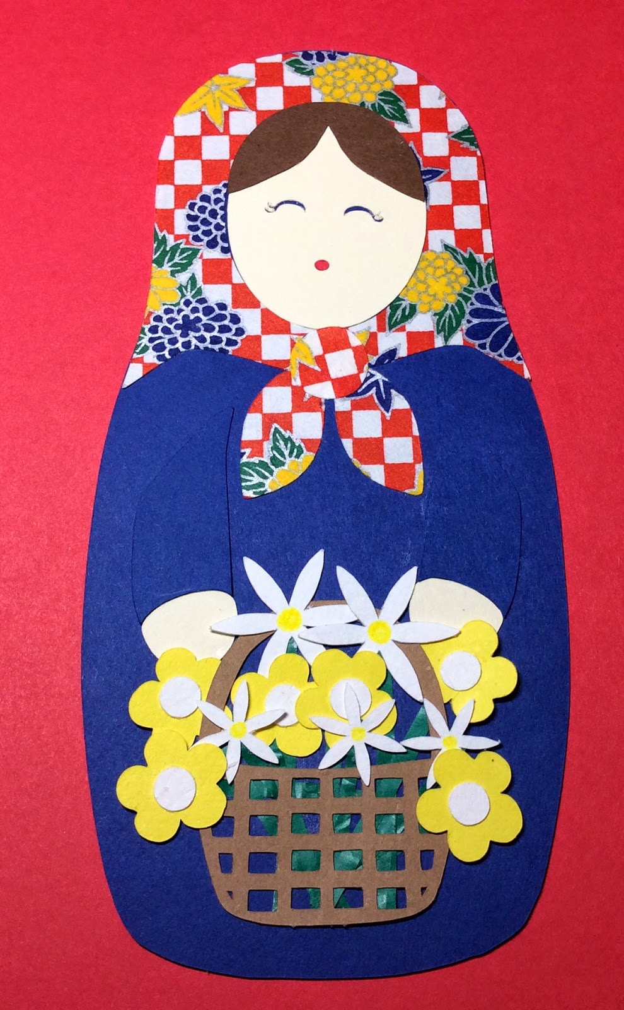

Russian Doll Holding a Basket of Flowers

I used colorful origami paper for my Russian Paper Doll's kerchief. The rest of the doll was made with cardstock. Please see the attached files to make your own Russian Paper Doll!